Call for Papers | International Island Forum 2023

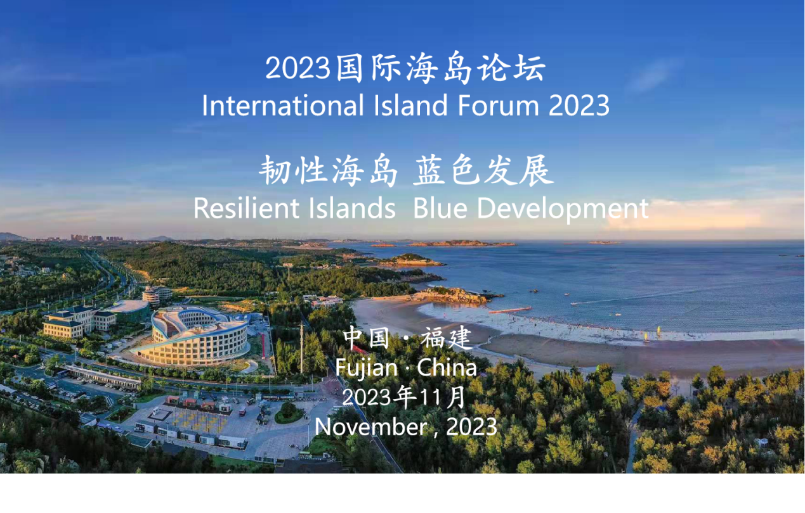
Background

As an important part of marine sustainable development, sea islands play an increasingly important role in promoting the process of achieving the UN Sustainable Development Goals. Island Research Centre of Ministry of Natural Resources, in collaboration with China Oceanic Development Foundation and other partners, will organize the International Island Forum 2023. The forum is planned to be held in Fujian Province in November 2023 (arrangements to be announced in due course). To strengthen academic exchange, we hereby solicit manuscripts from all colleagues. Relevant matters are notified as follows:
- Forum theme
Resilient Islands Blue Development
- Special topics
Including, but not limited to:
- Climate Change, and Disaster Prevention and Mitigation;
- Island Spatial Planning and Sustainable Utilization of Island Resources;
- Marine Ecosystem Protection and Restoration;
4. Ocean Finance and Blue Partnership;
5. Island Protection and Global Ocean Governance
- Paper requirements
1. The authors of papers may propose their own topics in relation to the Forum and their research expertise. Papers must be correctly oriented, comply with academic writing norms and academic ethics, focus on academic innovation and practicality, and be in English or Chinese.
- The content of the thesis should include: title, author's name and affiliation, abstract, keywords, as well as the body and conclusion, etc. Original and unpublished papers are encouraged.
For formatting guidelines: https://www.mdpi.com/journal/sustainability/instructions
- Please indicate the author's name and contact information (email and mobile phone number) when submitting your paper to facilitate contact with the conference team.
- Contact details and deadline
Authors are requested to send their papers as email attachments to the contact person's email address by 15 September 2023.
Contact information:
Zheng Qinqin +86-13850167747 zhengqinqinIRC@163.com Deng Yuncheng +86-15960210295 dengyuncheng2006@163.com
- Other information
- Participants who submit papers will be exempted from the registration fee;
- Selected papers will be published in a conference proceedings book or a special issue of a related academic journal after the forum. The academic publications will be announced soon.
- More information regarding the forum's program, venue, and arrangements will be announced in due course.

